**Visual Studio Code的安装教程**

**下载**

[Visula Studio Code官网下载](https://code.visualstudio.com/)对应win系统或macOS系统的文件，双击安装即可，无需额外配置.

**插件安装**

第一步：选中扩展选项卡

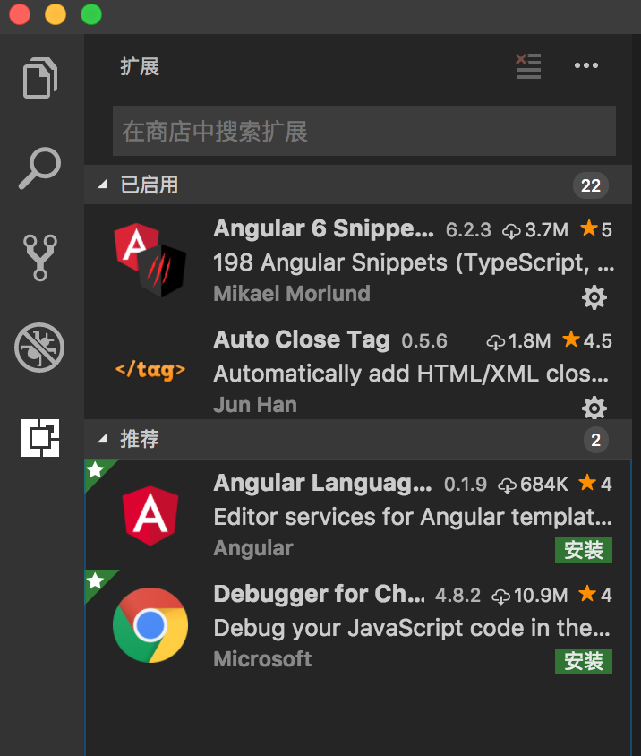

第二步：输入搜索想要的插件

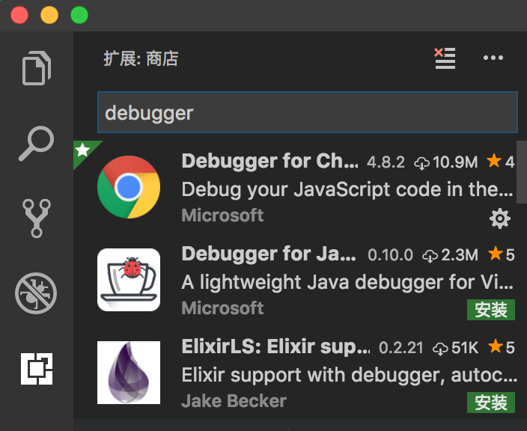

第三步：点击安装

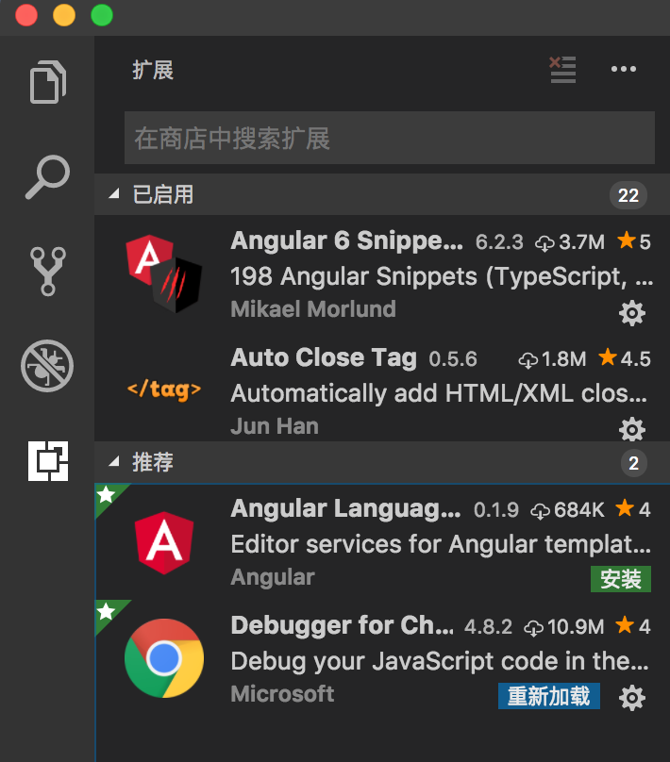

第四步：点击重新加载即可完成安装



**附：**

**常用插件的安装**

[Auto Close Tag](https://marketplace.visualstudio.com/items?itemName=formulahendry.auto-close-tag) — 自动闭合HTML标签

[Auto Rename Tag](https://marketplace.visualstudio.com/items?itemName=formulahendry.auto-rename-tag) — 修改HTML标签时，自动修改匹配的标签

[background](https://marketplace.visualstudio.com/items?itemName=shalldie.background) — 背景

[beautify](https://marketplace.visualstudio.com/items?itemName=HookyQR.beautify) — javascript, JSON, CSS, Sass, HTML 代码高亮

[Beautify css/sass/scss/less](https://marketplace.visualstudio.com/items?itemName=michelemelluso.code-beautifier) — 代码高亮

[CSS Peek](https://marketplace.visualstudio.com/items?itemName=pranaygp.vscode-css-peek) — 自动查找CSS文件

[Debugger for Chrome](https://marketplace.visualstudio.com/items?itemName=msjsdiag.debugger-for-chrome) — 调试JavaScript

[Easy Sass](https://marketplace.visualstudio.com/items?itemName=spook.easysass) — scss/sass文件保存可自动生成并同步编译成同名css文件

[Git History](https://marketplace.visualstudio.com/items?itemName=donjayamanne.githistory) — git log

[GitLens](https://marketplace.visualstudio.com/items?itemName=eamodio.gitlens) — 显示文件最近的commit和作者,显示当前行commit信息

[HTML Class Suggestions](https://marketplace.visualstudio.com/items?itemName=AndersEAndersen.html-class-suggestions) — 类名命名提示

[HTML CSS Support](https://marketplace.visualstudio.com/items?itemName=ecmel.vscode-html-css) — CSS的智能补全

[HTML Snippets](https://marketplace.visualstudio.com/items?itemName=abusaidm.html-snippets) — 回车或tap生成标签

[Indenticator](https://marketplace.visualstudio.com/items?itemName=SirTori.indenticator) — 缩进高亮

[IntelliSense for CSS class names](https://marketplace.visualstudio.com/items?itemName=Zignd.html-css-class-completion) — CSS类名智能命名提示

[JavaScript (ES6) code snippets](https://marketplace.visualstudio.com/items?itemName=xabikos.JavaScriptSnippets) — JS语法提示

Debugger for Chrome —映射vscode上的断点到chrome上，方便调试

ESLint —— js语法纠错，可以自定义配置

[TSLint （Visual Studio Marketplace](https://link.zhihu.com/?target=https%3A//marketplace.visualstudio.com/items%3FitemName%3Deg2.tslint)）校验ts语法。

参考文档地址：

https://segmentfault.com/a/1190000006697219